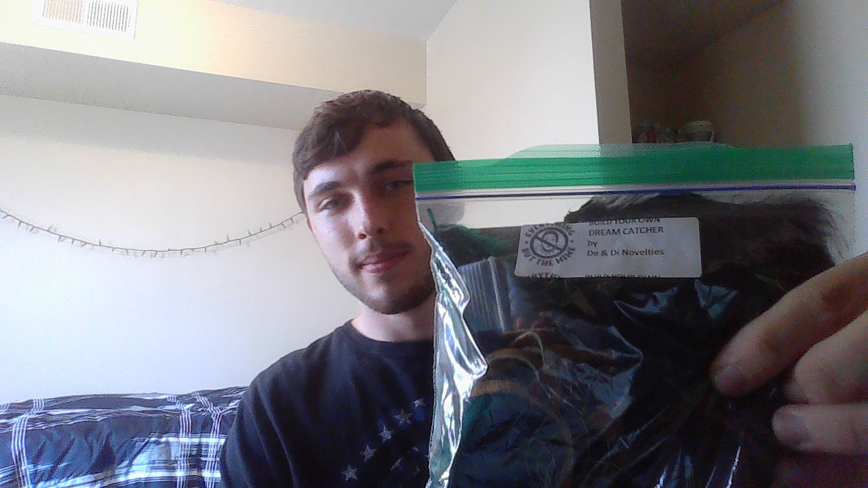

I got one of the Wednesday crafts again, they have been keeping me busy when I’m bored and it’s something fun to do. It’s harder to make friends in person and in getting bored of the internet, I know right. Its nice to do have a physical project every once and a while. I don’t know where I’m going to put this dream catcher, but I’m excited. Not going to lie, its very lonely since I’ve been to TAMUCC and I’m starting to struggle a bit. But I will get through. I just need to find a new outlet.